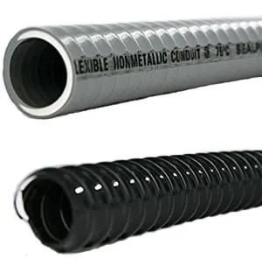Liquid Tight Conduit

Liquid Tight Conduit
- Use a liquid tight ﬂexible conduit a conductors with a nominal rating of
- Sizes 3/8" to 2"
- Integral rigid and ﬂexible PVC cons
- Dry temp. rating: 0º to 176º F (-18
- In Oil temp. rating: up to 160º F (70
- Wet temp. rating: up to 140º F (60º
- Use straight-thru and right-angle c

